Chapter 18, Problem 41.

Determine the Fourier transform of v(t) in the circuit shown in Fig. 18.43.

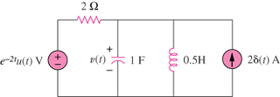

Figure 18.43
For Prob. 18.41.

